VOLCANOES

Many cone-shaped mountain peaks were formed by volcanic eruptions. All have a funnel-shaped depression at the top.

There are three different types of volcanoes (based on their appearance and structure).

1. CINDER CONES
• Smallest and most common.
• Made up of small, hot bits of cinder rock that cool rapidly.
e.g. Paricutin in Mexico.

2. SHIELD CONES
• Largest volcanoes.
• Made up entirely of lava flows which build up gradually on the outside to form the mountain.
e.g. Hawaiian Islands.

3. COMPOSITE CONES
• Made of alternating layers of cinder rock and hardened lava.
• Most famous explosions are of this type.
e.g. Mt Vesuvius, Mt St Helens, Mt Fujiyama.

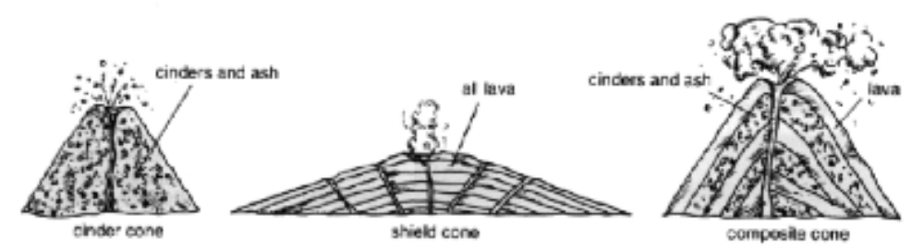

LAVA FLOODS AND EXPLOSIONS

Lava can be either free-flowing or thick and sticky.

Free-flowing lava floods out of the volcano and covers vast amounts of low-lying land.

Thick lava may solidify in the vent or opening of the volcano. This causes a huge build-up of pressure within the volcano and may cause it to bulge. Finally it will explode as it releases the pressure.

These explosions are very violent. When Krakatoa in Java exploded in 1883, scientists believe it is the only explosion that could have been seen from space. The tsunami (giant wave) it produced caused massive devastation and was reported to be over 30 m high.

